1

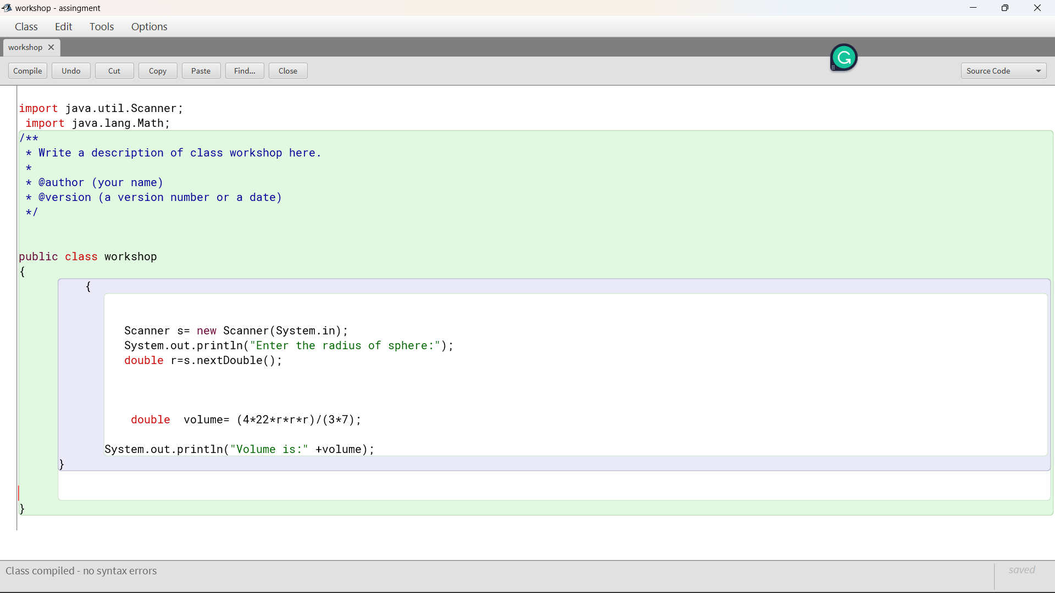

B. Pseudocode

START

1. INITIALIZE Pi, Pi = 3.14149

2. PROMPT the user to enter the radius of the sphere

3. READ the radius of the sphere, r

4. COMPUTE for the volume of the sphere, V = (4.0/3.0) * Pi * r3

5. WRITE the volume of the sphere, V

END

. Pseudocode

START

INITIALIZE Pi, Pi = 3.14149 2.

PROMPT the user to enter the radius of the sphere

READ the radius of the sphere, r

COMPUTE for the volume of the sphere, V = (4.0/3.0) * Pi * r3

WRITE the volume of the sphere, V

END

B. Pseudocode

START

1. INITIALIZE Pi, Pi = 3.14149

2. PROMPT the user to enter the radius of the sphere

3. READ the radius of the sphere, r

4. COMPUTE for the volume of the sphere, V = (4.0/3.0) * Pi * r3

5. WRITE the volume of the sphere, V

END

B. Pseudocode

START

1. INITIALIZE Pi, Pi = 3.14149

2. PROMPT the user to enter the radius of the sphere

3. READ the radius of the sphere, r

4. COMPUTE for the volume of the sphere, V = (4.0/3.0) * Pi * r3

5. WRITE the volume of the sphere, V

END

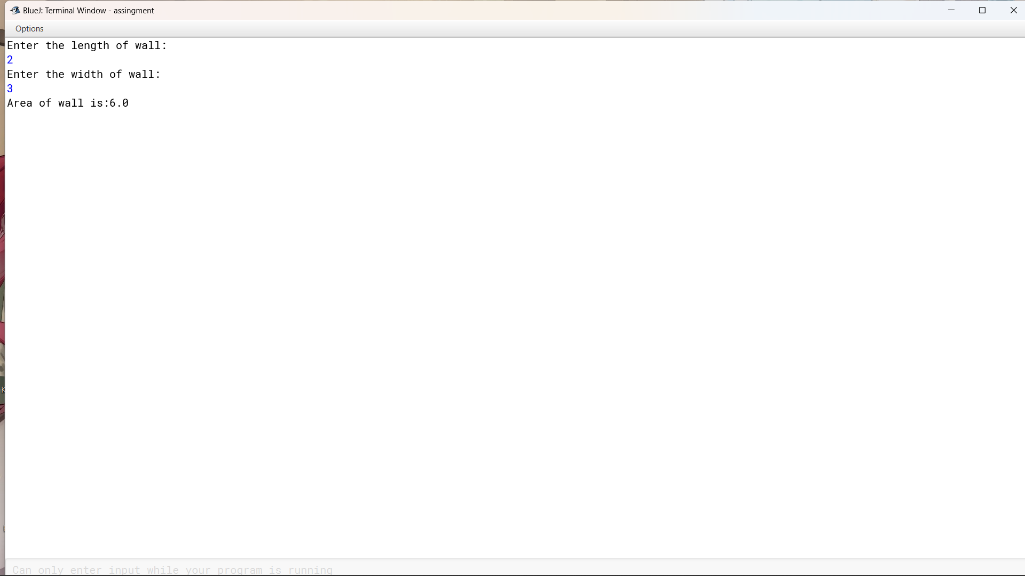

3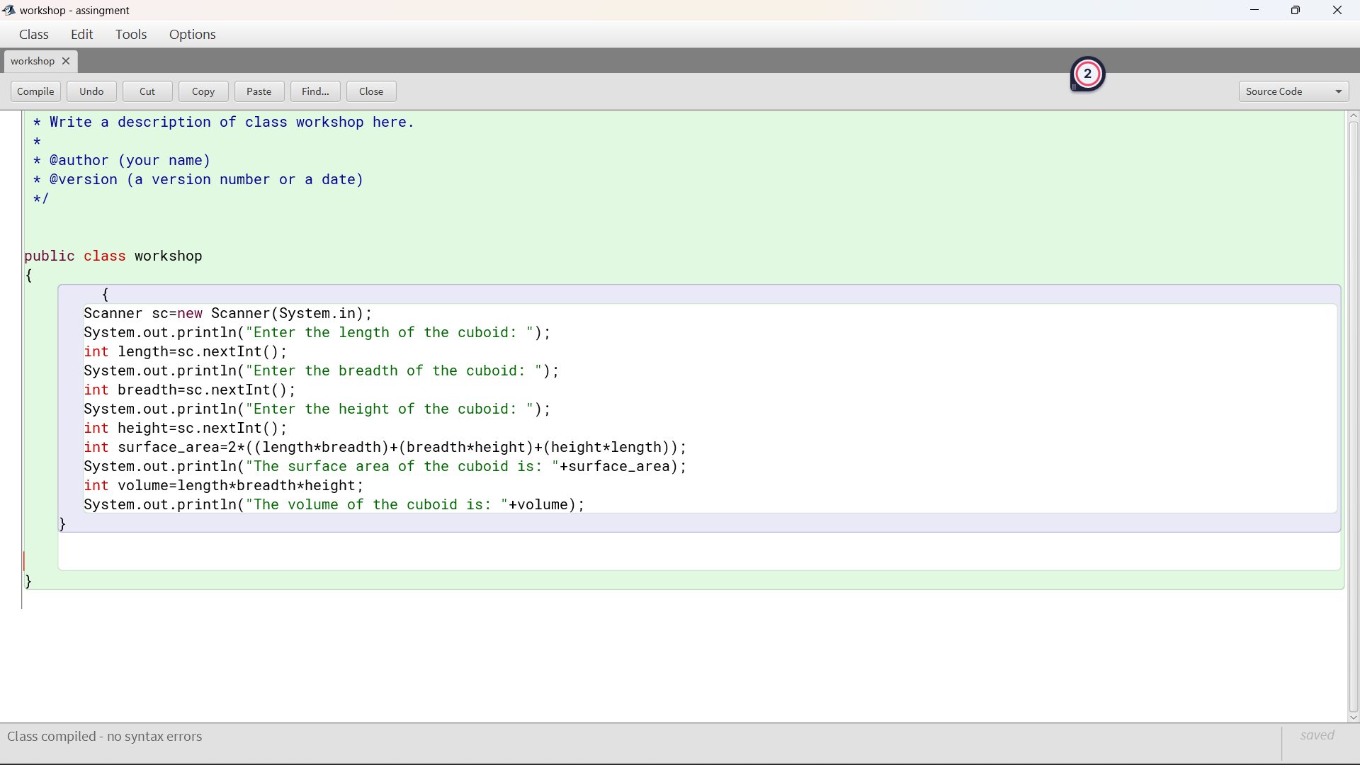

Pseudocode

Initialize l,b,h,TSA,v as int

Compute TSA and volume

TSA =l*b+b*h+h*l+l*b+h+h*l

V= l*b*h

Print TSA and volume

4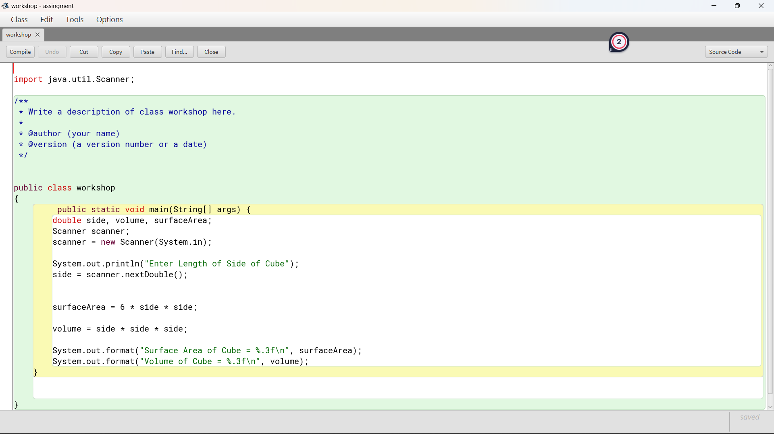

Pseudocode:

Initialize L.

Compute for the area of one face, a=l*l.

Compute for the TSA, tsa=6*l.

Compute for the area of one face, volume=l*l*l.

Print(tsa, volume)

Pseudocode

Initialize l, b, a as int

Compute a=l*b

Print

Pseudocode

Initialize r,p,t,intrest,totalamount as double

Compute intrest=p*t*r/100

Compute total amount = intrest+p

Print

7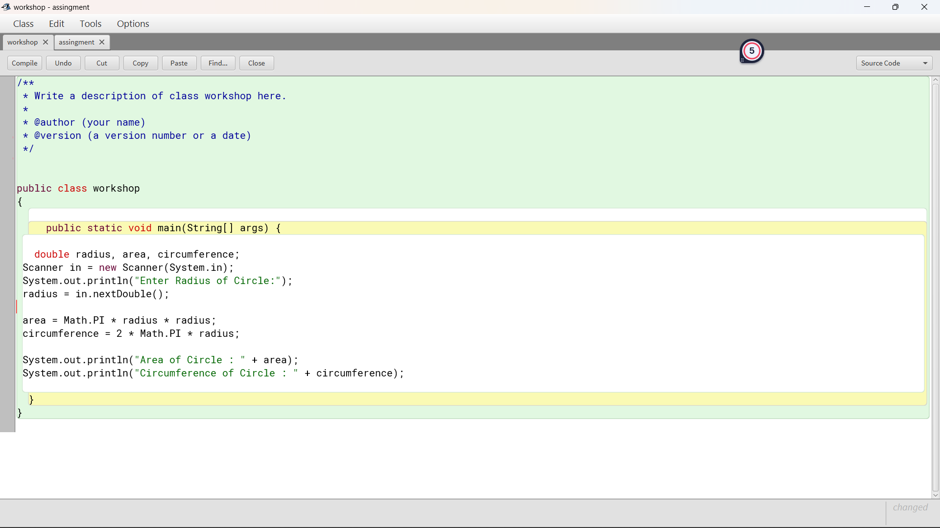

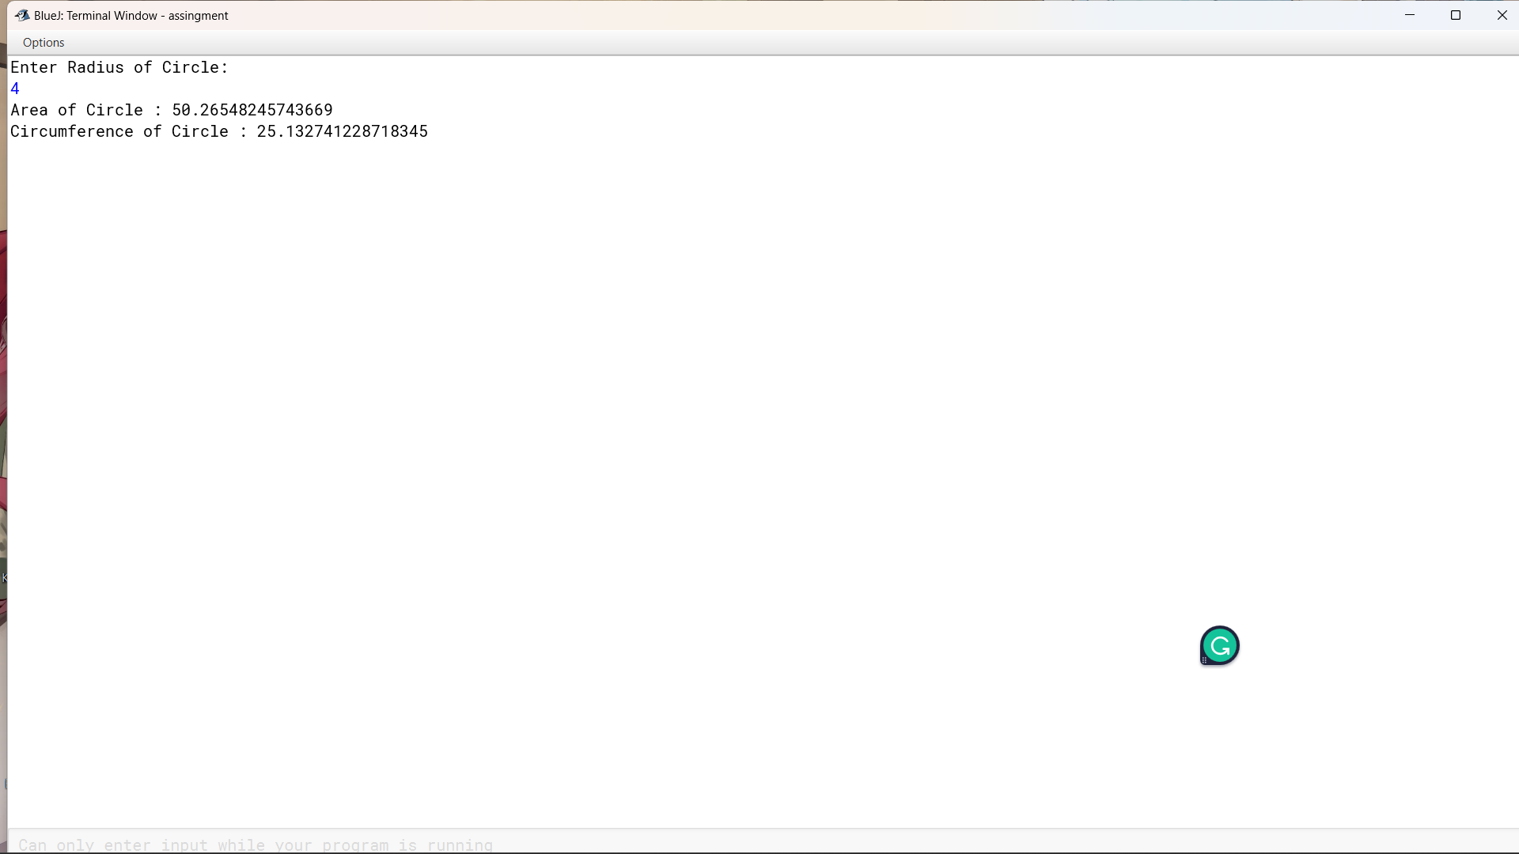

Pseudocode

Initiliaze r as int

Pi ,c ,area as double

Compute C=2*r*pi

Compute Area=pi*r*r

Compute area and c

print

8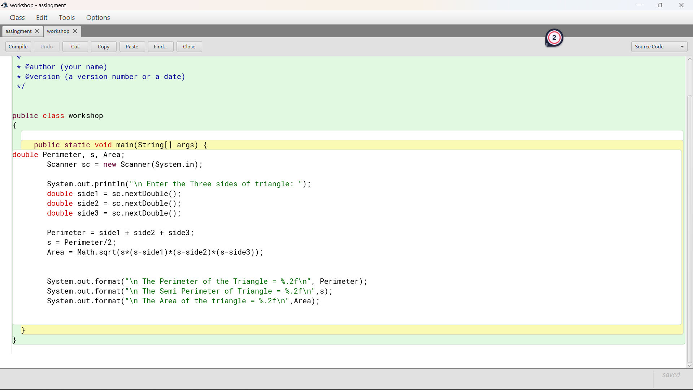

Pseudocode

Initialize a, b , c, t as int

Initialize x, y, z, aa, area as double

Compute t=a+b+c/2

Compute x=t-a

Compute y=t-b

Compute z=t=c

Compute aa=t*x*y*z

Compute area= math.sqrt(aa)

Print

9

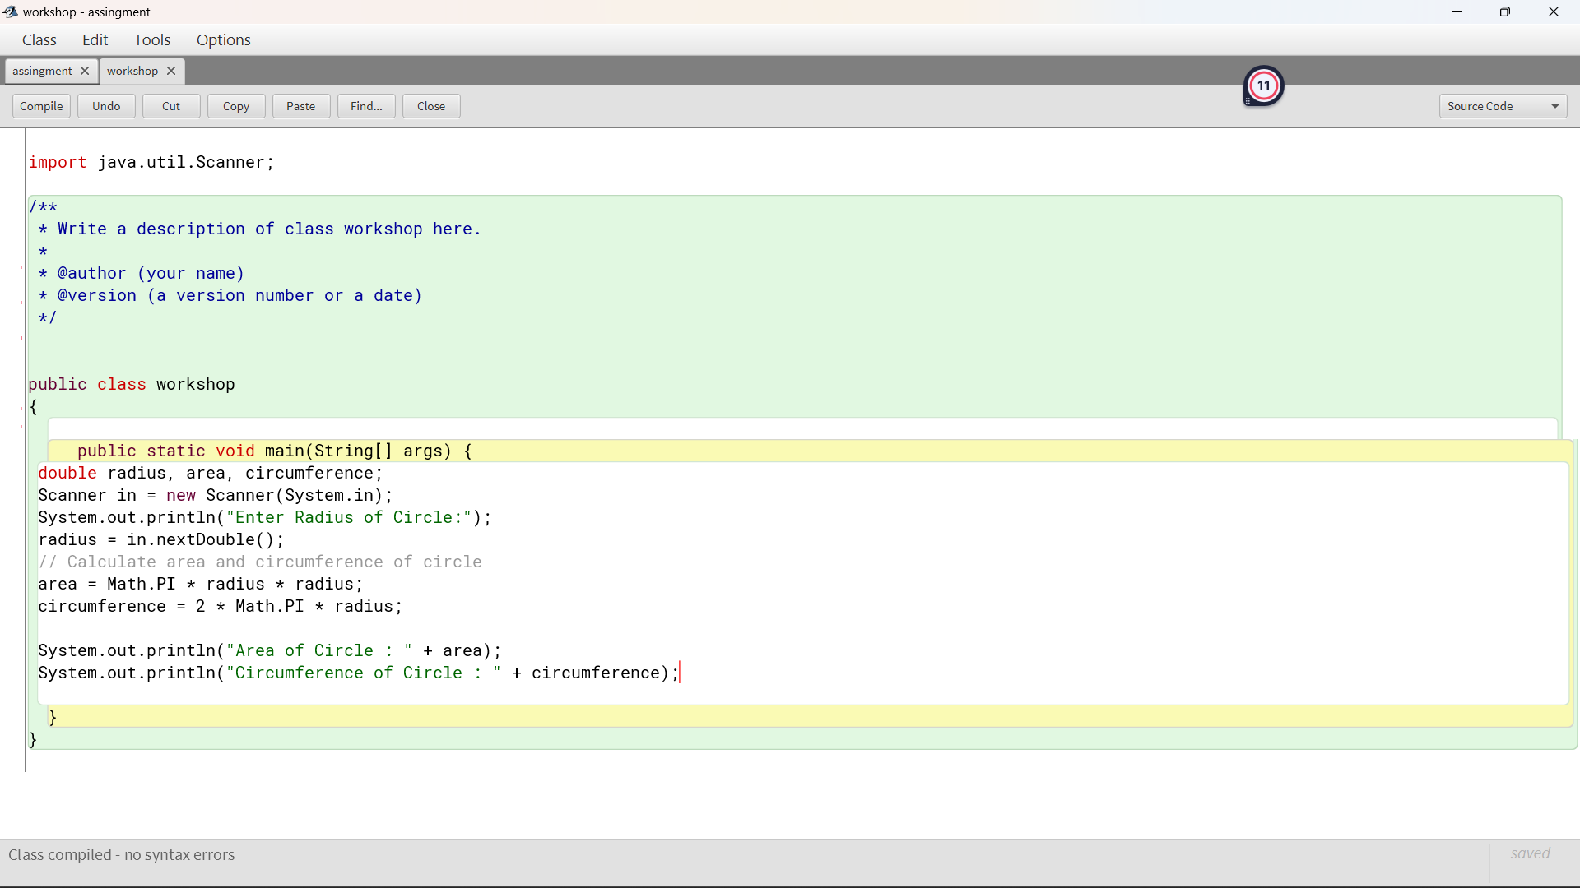

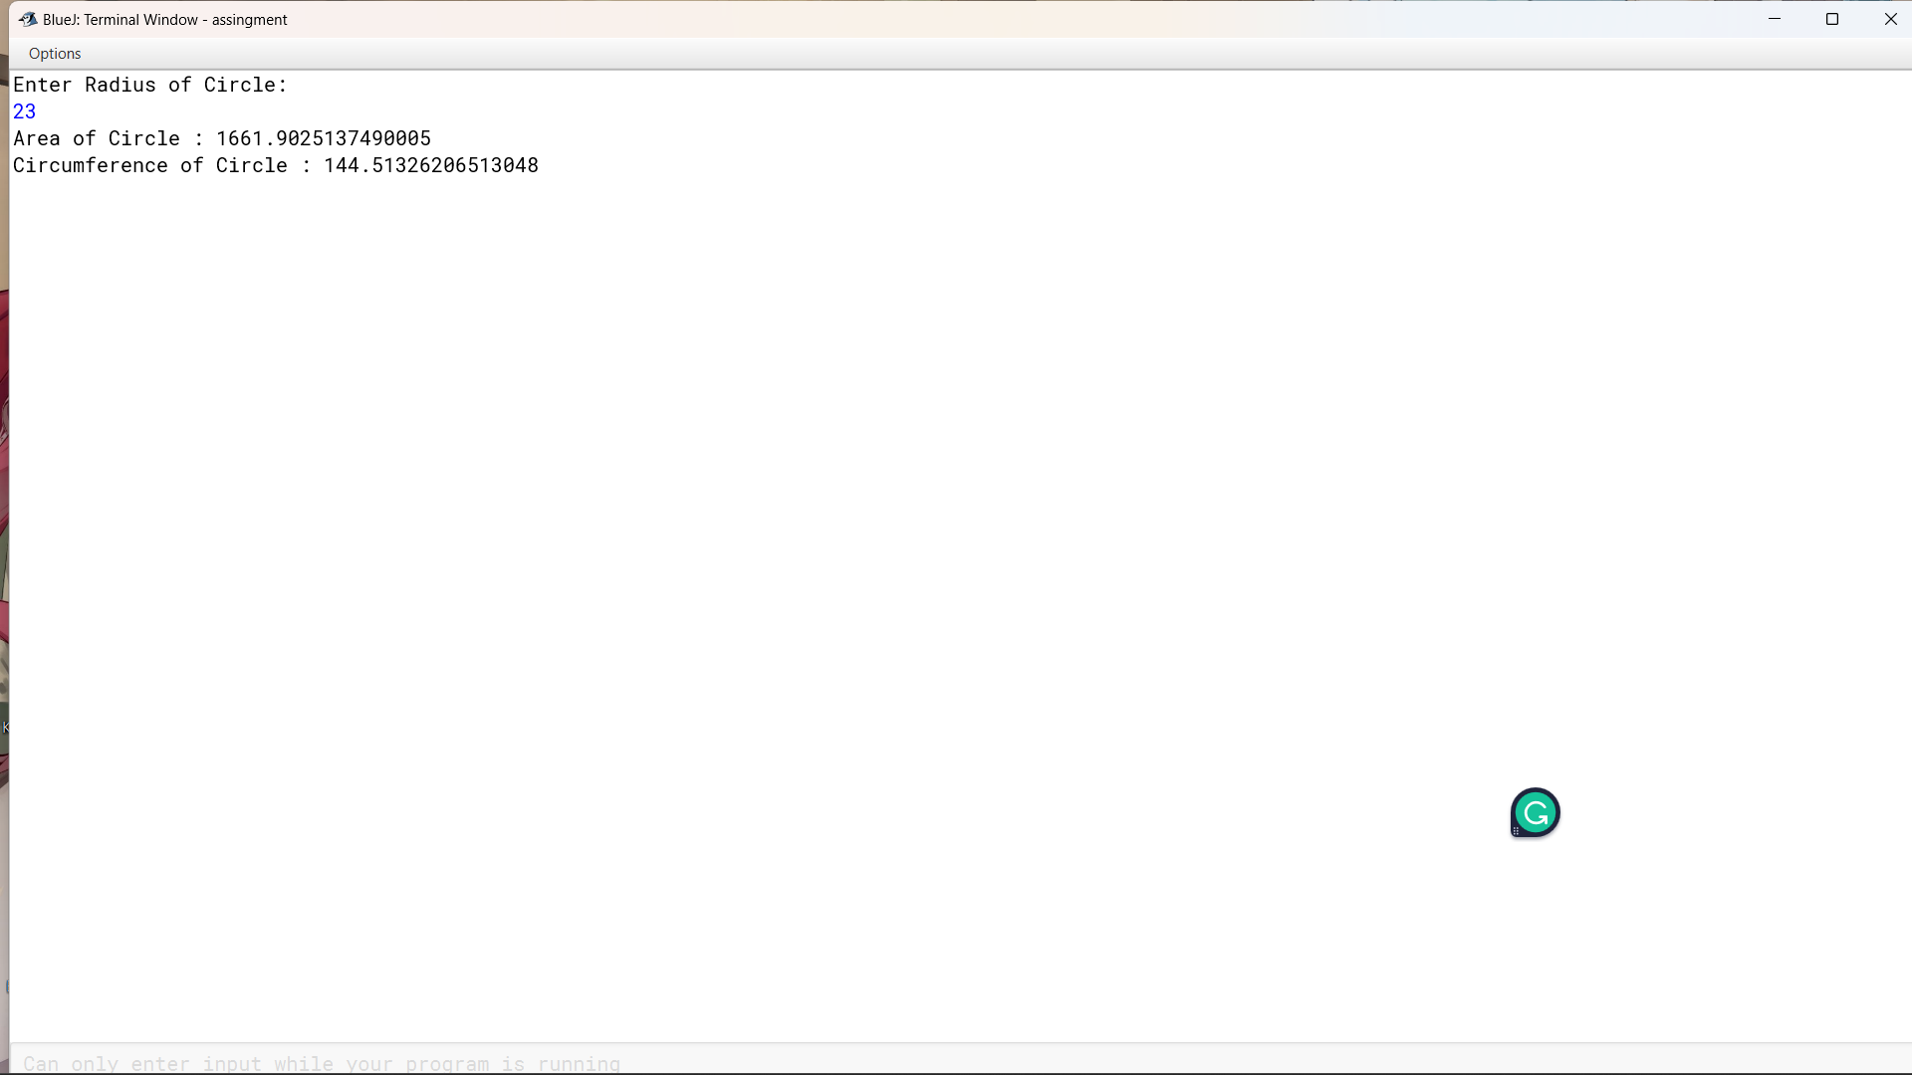

Pseudocode

Initiliaze r as int

Pi ,c ,area as double

Compute C=2*r*pi

Compute Area=pi*r*r

Compute area and c

print

10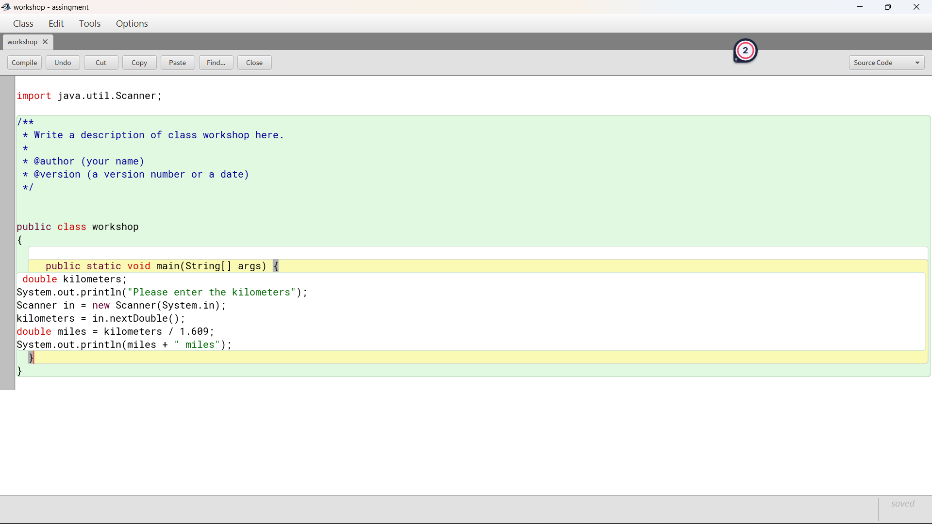

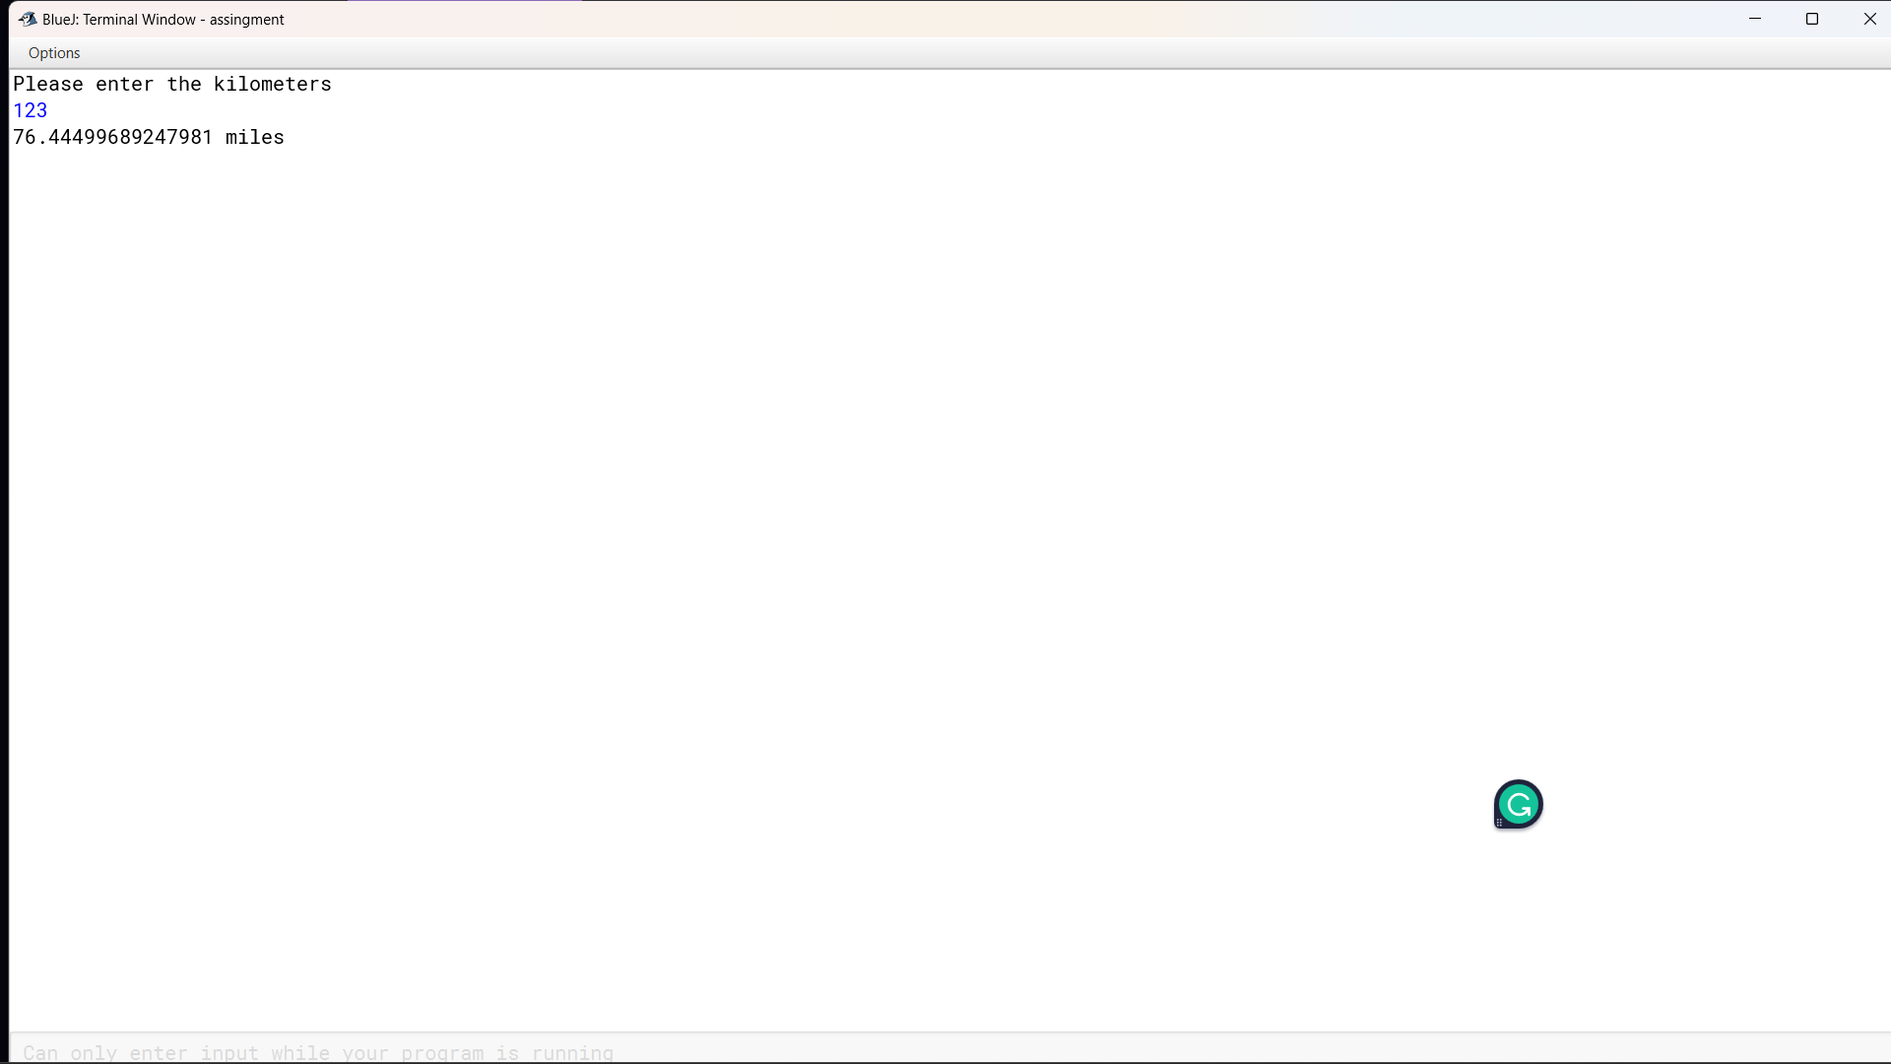

Pseudocode:

Initialize kg by taking input from the user.

Compute for the g, g=kg*1000;

Print(g)

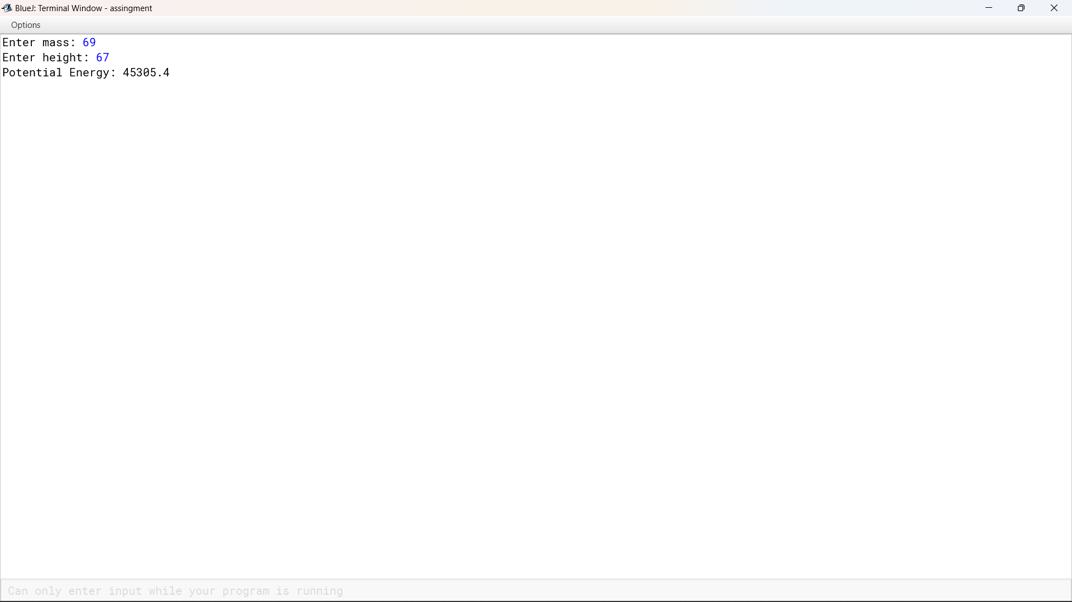

Pseudocode:

Initialize u, t, and a by taking input from the user.

Compute for the total displacement, S=u*t+(a*t*t)/2.

Print(s)

12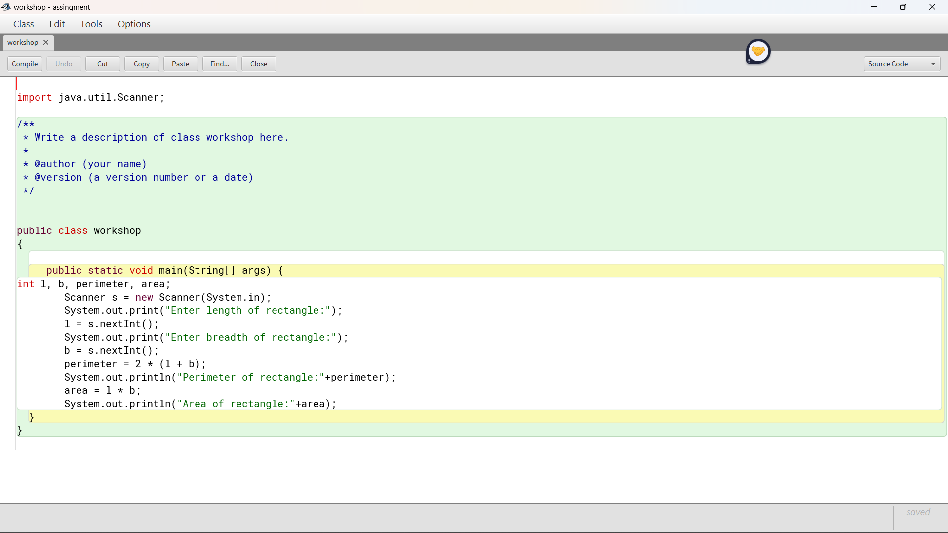

Pseudocode

Initialize l, b, p

Compute p=2*(l*b)

Compute a=l*b

Print

13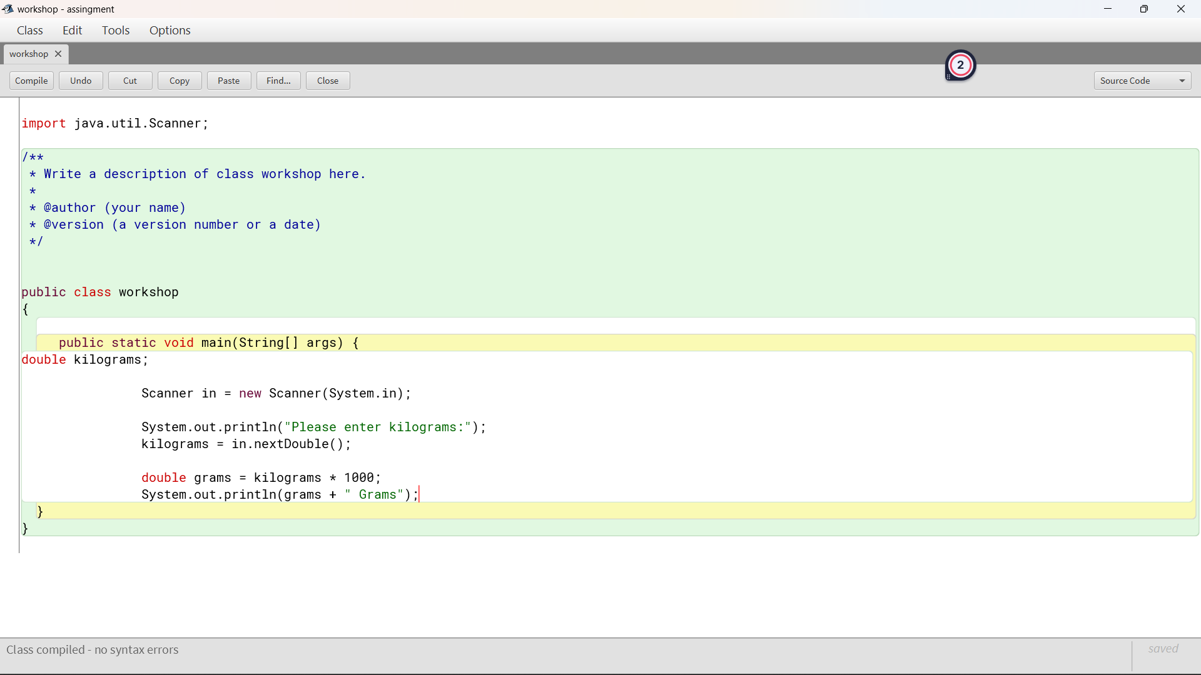

Pseudocode:

Initialize kg by taking input from the user.

Compute for the g, g=kg*1000;

Print(g)

14

**Pseudocode**

**Initialize r as int and pi and v as double**

**Compute volume of sphere, v=4.0/3.0*pi*r*r*r**

**Print v**

15

Initialize r, h as int

Pi,tsa,volume as double

Compute Tsa=(2*pi*r*h)+(2*pi*r*h)

print

16

Pseudocode

Initialize r as int

Pi, TSA, volume as double

Compute TSA=4*pi*r*r

Print

17

Pseudocode:

Initialize u, t, and a by taking input from the user.

Compute for the total displacement, S=u*t+(a*t*t)/2.

Print(s)

18

Pseudocode:

Initialize L.

Compute for the area of the square, area=l*l.

Print(area)

19

Pseudocode:

Initialize i and sum.

Make a condition where i is increased by 1, i=1, i&lt;=n, i++.

Compute for the sum, sum=sum+i.

Print(sum)

20

21

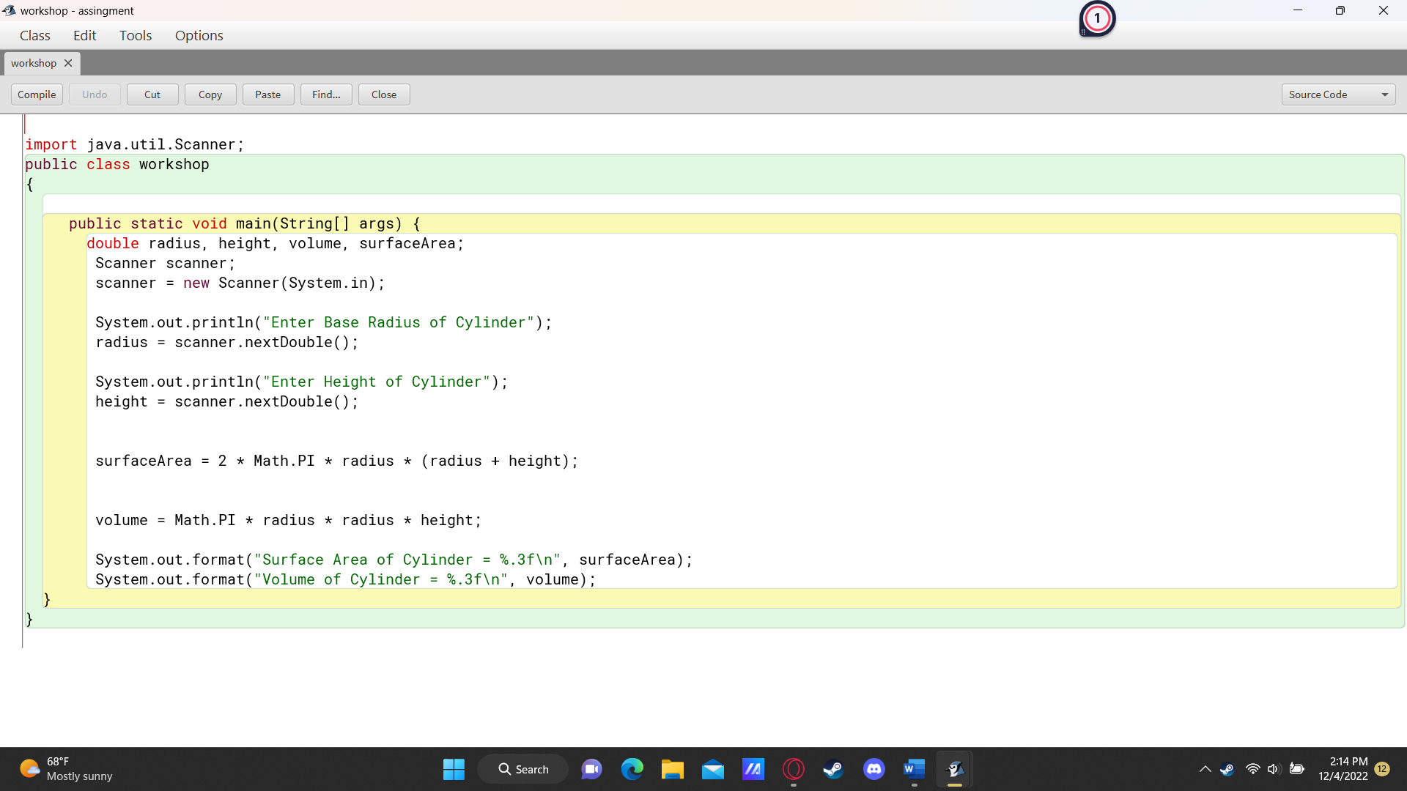

Pseudocode

Initialize r, h as int

Pi,tsa,volume as double

Compute Tsa=(2*pi*r*h)+(2*pi*r*h)

Compute Volume=pi*r*r*h

print

22

Pseudocode:

Initialize marks of science, maths , moral and social by taking input from the user.

Compute for pass, marks&gt;=40.

Compute for fail,else=fail.

23

Pseudocode:

Initialize L.

Compute for the Volume of the cube, v=l*l*l.

Print(v)

24

Pseudocode:

Initialize l,b, h.

Compute for the volume of the cuboid , volume=l*b*h.

Print(volume).

25

26

Pseudocode:

Initialize pi, r.

Compute for the volume, volume=(pi*r*r*r*2)/3

Print(volume).

27

28

Pseudocode:

Initialize paisa by taking input from the user.

Compute for the rupees, rupee=paisa/100.

Print(rupee)

29

30

31

